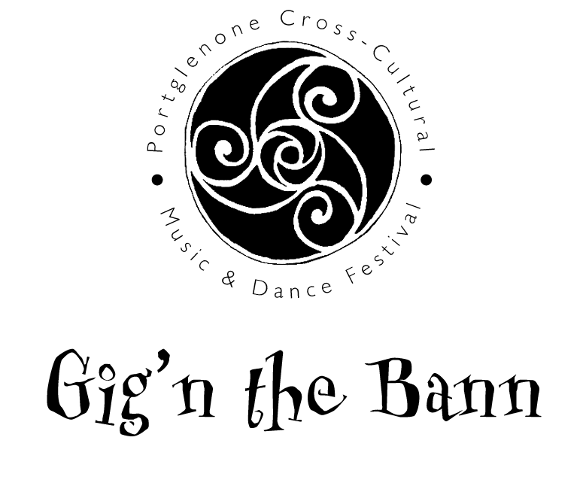
presents
Young Band Competition 2013

- Six finalists will be selected by the competition committee and invited to perform in a live final at the Gig’n the Bann Festival, held in Portglenone on 8th September 2013.

- Things taken into consideration will be:
  - Musicality
  - Quality of performance
  - Presentation and interaction with the audience – the bands should treat the competition as a mini-gig. Sets should be introduced with a brief background into the tunes.

- Bands should have a minimum of 3 and a maximum of 8 members.

- Three sets of music/songs should be arranged for the performance and the overall performance should take no more than 12 - 15mins.

- Each member of the band must be aged between 14 and 25 inclusive on the 1st September 2013

- Below is the genres of music eligible for the competition:

  - Irish traditional
  - Folk
  - Ulster Scots
  - Piping
  - Gospel

- To enter:
Fill out the attached form and email, along with a recording of the band to the email address at the bottom of the form.

Entries must be completed and received on or before 28th June 2013.
Finalists will be notified on or before 31st July 2013.

For further information an email can be sent to
ryan391@hotmail.com
Young Band Competition Entry Form

Live Final will be held on
Sunday 8th September 2013
In The Wild Duck, Riverside Suite

PRIZES: 1st £400 (plus an opportunity to perform at Gig’n the Bann 2014)
2nd £200

Please complete the following for each band member:

Name | Date of Birth

Main Contact Name & Number: _______________________________________
Email: ___________________________________________________________

Email your entry to ryan391@hotmail.com

If you wish to post your entry please contact Ryan Graham at the above email address.

